8. Write a C program to search a number using Linear Search method

Program:

#include <stdio.h>

int linearSearch(int arr[], int n, int key) {

for (int i = 0; i < n; i++) {

if (arr[i] == key) {

return i;

}

}

return -1;

}

int main() {

int arr[] = {12, 45, 67, 89, 34, 56};

int n = sizeof(arr) / sizeof(arr[0]);

int key = 67;

int result = linearSearch(arr, n, key);

if (result == -1) {

printf("Element not found\n");

} else {

printf("Element found at index: %d\n", result);

}

return 0;

}

Input:

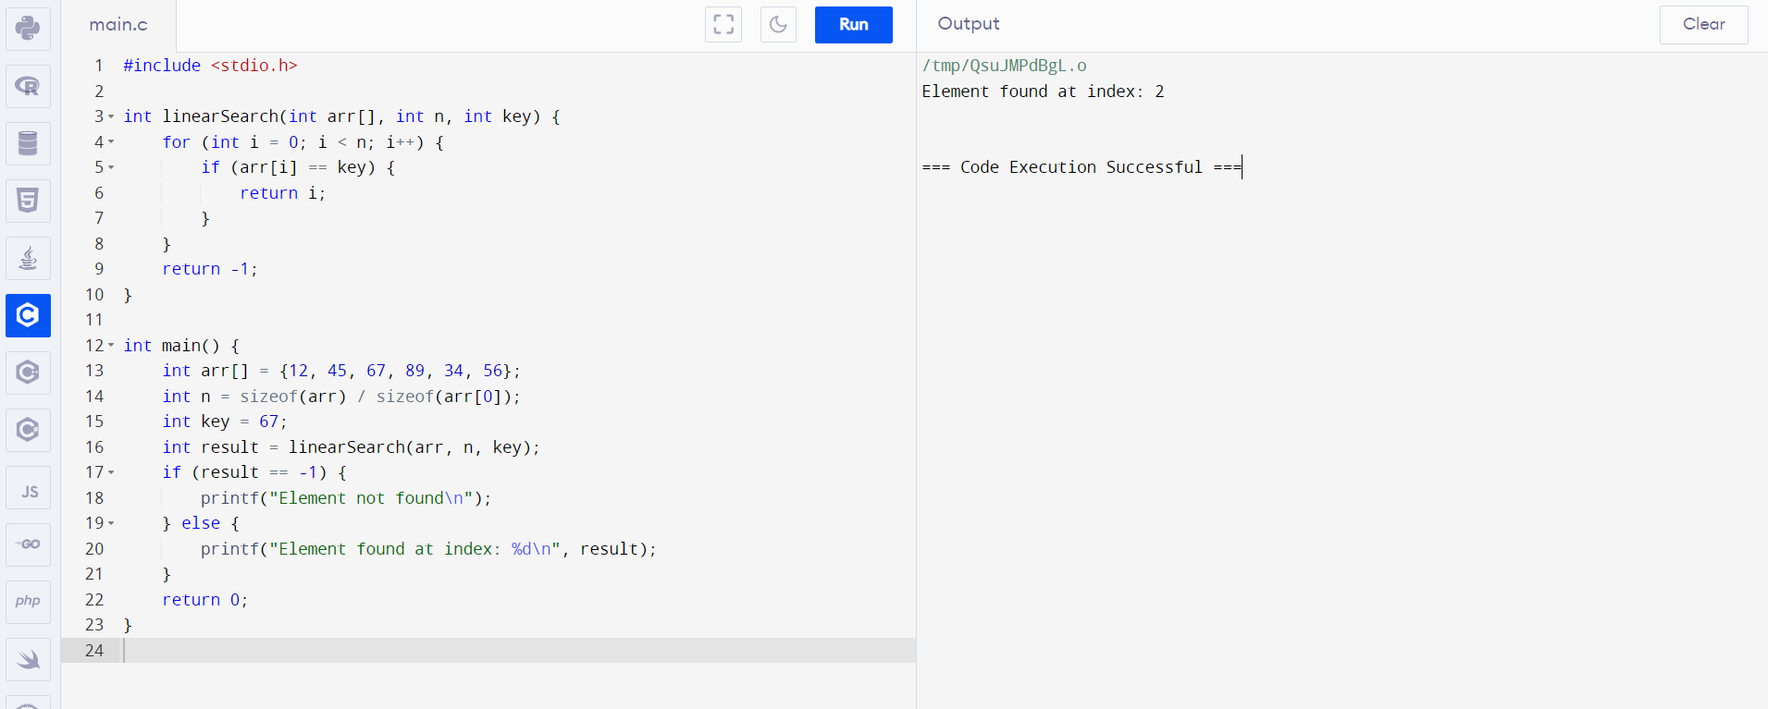

Output:

